Abstract— The billing process at the big stores like Kroger and Walmart is time consuming and cumbersome. We want to make that process easy and frictionless. Taking just a picture of objects would identify the products in the image and their corresponding quantities which would help in faster and more convenient checkout.
Grocery Product Recognition
Nithish Kandagadla, Amit Makasir, Gurjaspal Singh Bedi, Indiana University, Bloomington

INTRODUCTION

A. Overview of the Project
The Electroencephalogram-Robot is robot that can be directed (locomotion) using the signals from the EEG (Electroencephalogram). Electroencephalogram (EEG) is a device that is used to record the brain activity at different regions of the brain. It can help in recording the activity in micro-volts with respect to time. I used existing dataset which I obtained from Kaggle [1] competition to write a Machine Learning classifier that classified the subjects hand actions into two classes. Based on these two classes, the input is given to the robot as increase in linear velocity and angular velocity. The two hand activities I used were the “Hand Started” and “Both Released”.

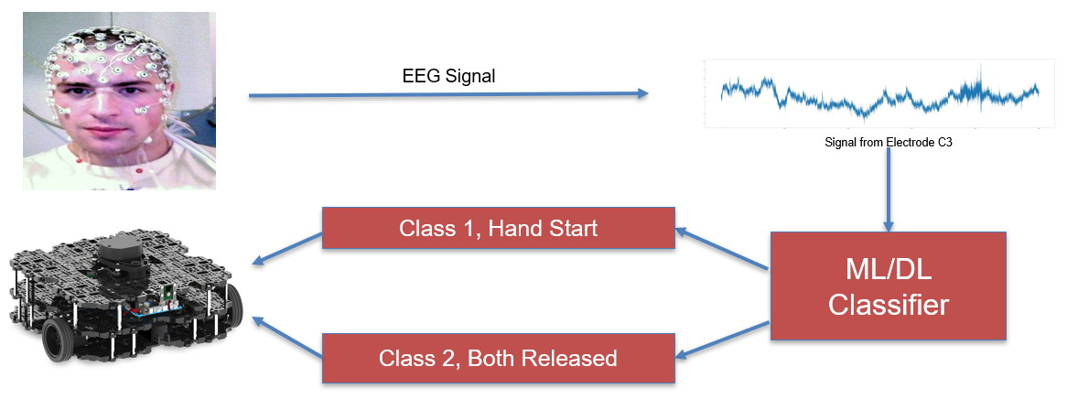

B. Overview of the Data
This data was originally collected by Mathew D Luciw, Ewa Jarocka & Benoni B Edin [4]. 3,936 grasp and lift trials were done on 10 subjects. In the experiment, EEG with 32 channels was used to get the brain activity, five EMG sensors to record hand movements. More detail regarding the data collection can be found here. The Kaggle dataset which I used was subset of the complete dataset. Out of 6 classes of labeled data, I used the two of them, which are Hand Start and Both Released.

C. Machine Learning Classifier & Tools
Support Vector Machines with the polynomial kernel having a degree of two used after trying a few other classifiers before. The details of all classifier used will be in the Main Methods section. Rviz with ROS API on Ubuntu was used for simulation of the Robot (Turtlebot3).

Main METHODS

A. DATA USED
We clicked 180 images of the grocery products and then augmented them by rotating and resizing (342 x 342). The final count of the images after the data augmentation is 720. The images contain 10 different products in different possible combinations. We created the bounding boxes for all the products in the each image using Labelimg.

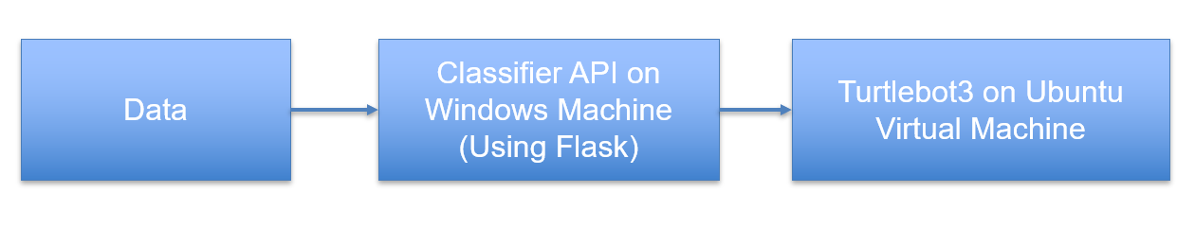
- Flask API: Flask was used to write an API that can be hosted in the host machine (Windows) and then from the Ubuntu (virtual machine) a call can be made to the host machine API to get the output on the virtual machine.
- The host machine IP is http://10.0.2.2 if you want to make a call to API which is hosted on the host machine.
- Scikit Learn and Numpy python libraries were used for writing the classifiers and preprocessing of data wherever required.

B. Preprocessing of Data
Out of 10 subject’s data which was available only data from one subject was used for the classification and out of six labels only two labels were used for the training and then prediction.

The sample train and test date set in as shown below, The data was in CSV format. In training data, each column corresponds to the signal from one electrode of EEG. The data had around 100,000 records for one series and there were 10 such series of the date. Out of which 8 were used for training and testing purposes.

Training Data: Each column corresponds to the values from one of the 32 electrodes.

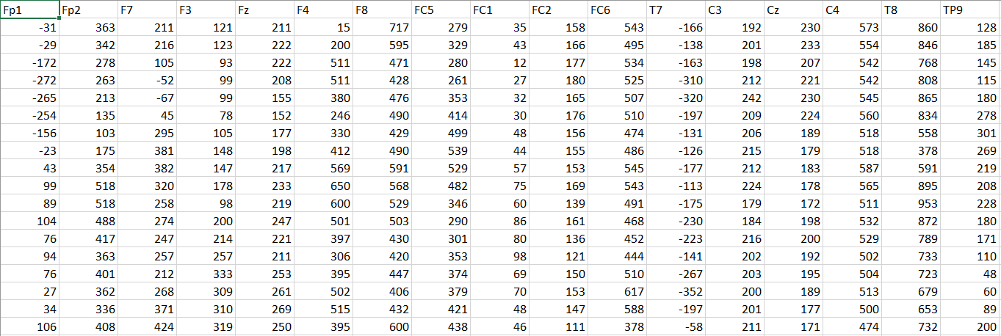

Testing Data
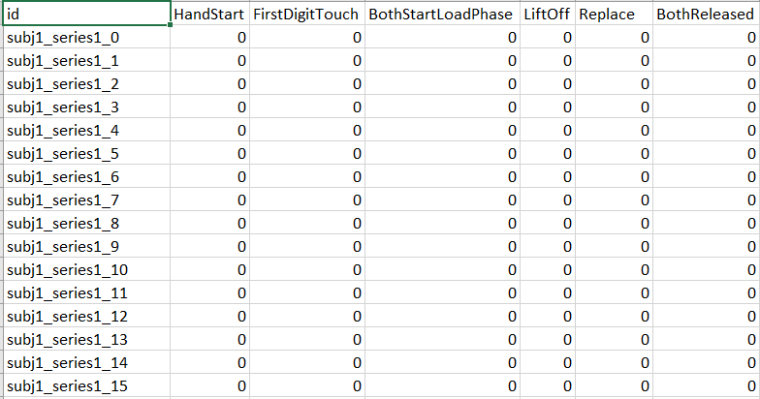

For the labeled data only two classes were used out of the six available classes.

C. Data Visualization
The EEG data of each electrode was visualized using the python library. In each visualization, the y-axis denotes the time and x-axis denote the voltage in micro-volts. Few sample visualizations are shown below.

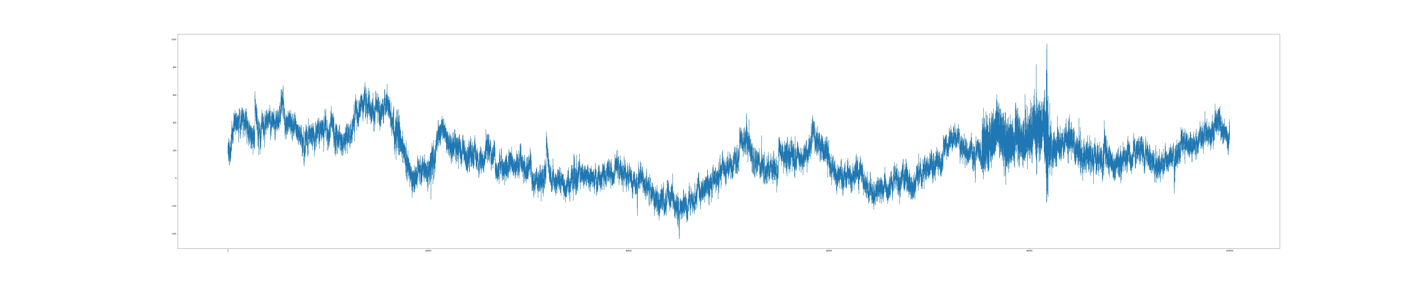
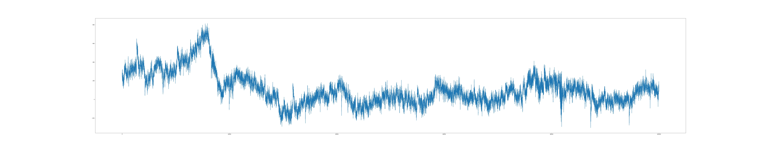

D. Machine Learning Classifiers
Following machine learning classifier were used before coming up with the final selection of classifier.
Perceptron: The accuracy for the perceptron classifier was very low. Just wanted to do experiment with this classifier.
Random Forest: It classified as continuous values rather than the binary values, also the performance was not that great.
Logistic Regression: Worked well for the given set of data but later I found that SVM is performing better given the speed and accuracy.
Support Vector Machines: Finalized on this classifier because of its high accuracy and speed when the large data set was used.

E. Different Classification Strategies used
With the help of one of the kernels available on the Kaggle website, I found that the electrodes on the left side of the subject’s brain have higher activity than the right side of the brain. This was due to the fact that only the right hand was used in the experiment. And of all the electrodes for the subject one, the activity was very high around the C3 electrode.
First, I tried taking data only from the C3 electrode and then from the nearby electrodes. Both the strategies didn’t work well for me. In the end, I planned to take the data from all the electrodes to get the desired accuracy for the classification. Below image shows the high activity in the left side of the subject one’s brain near the C3 electrode [2].

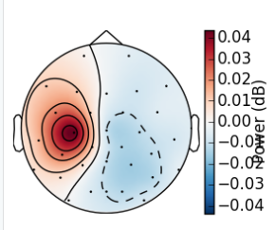

F. EEG 10-20 System
- For the 32 electrodes in the EEG, the standard system 10-20 was used for all the locations of the electrode. Here 10 refers to the distance in percentage between two electrodes when going from the left electrode to the right electrode and 20 refers to the distance in percentage between two electrodes when going from front to back. The design of the 10-20 system in as shown in the image below. The electrodes which are in black were used in the collection of data in the original experiment. This image is taken from the competition website on Kaggle.

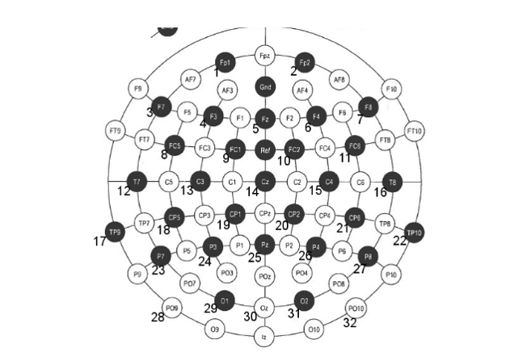

G. Experiment Video
- The video of the experiment that was performed to collect data can be found here.

H. ROS OPERATING SYSTEM
To navigate the robot based on the input, ROS API for Python was used on Ubuntu virtual machine. RVIZ was used to simulate the Turtlebot3 Robot.
I. SUPPORT VECTOR MACHINES
This report is incomplete without explaining briefly about the support vector machines. Support vector machine is a discriminative classifier. In simple words, given the labeled data the classifier can divide the data into categories of labeled data with a hyperplane.
In a simple version, SVM can only classify data which is linearly separable. For data which cannot be separated linearly different kernels are used. For example, polynomial kernel, RBF etc.
In this project, the SVM poly kernel was used with a degree of two.
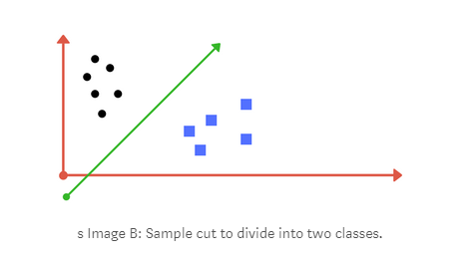
The image is taken from [3]

Related works
This project is inspired by the related project which was done by students of the University of Florida. They used a brain-computer interface and tried to control the drone just with their thoughts. They also organized a brain drone race where the drones were controlled by brain waves. The details regarding the brain drone race can be found here.
The video which demonstrates the drone developed by the University of Florida can be found here.

Results
The SVM classifier gave accuracy around 98%. The output of the classifier was given to the Turtlebot 3. If the predicted value of “HandStarted” the value of linear velocity was increased by 0.3 and when the predicted value was “BothReleased” then the angular velocity was increased by 0.3.

Screenshot of the hosted API on the windows machine
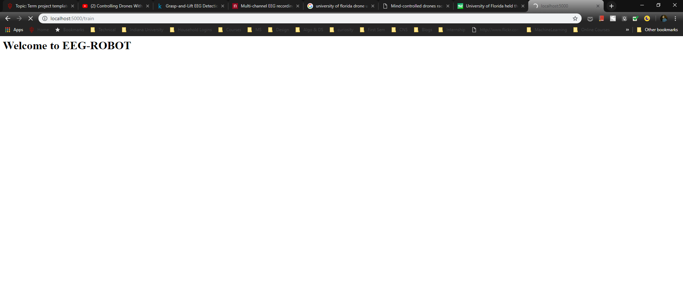
The classifier result screenshot. Accuracy above 98%.
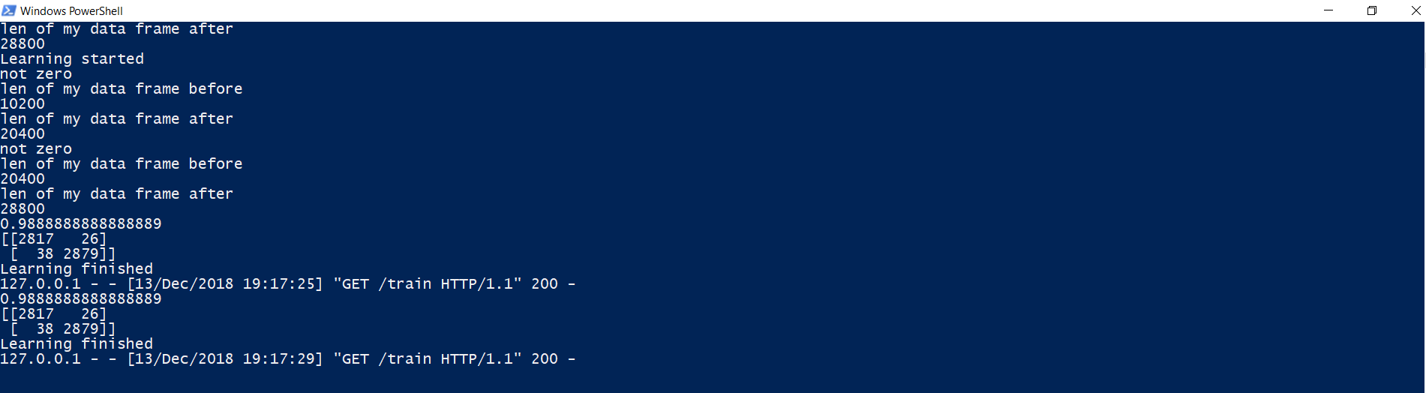

The video of the working project can be seen here.
Confusion Matrix Result of Classifier for a subset of data.

2817 | 26
38 | 2879

The results from another classifier used in the project were not recorded because they were not impressive enough. The best classifier SVM used as the final classifier for the project.
The final project version was able to successfully simulate the movement of the robot based on the EEG on the RVIZ using ROS on Ubuntu virtual machine.

discussion and future work
First, I would like to perform this experiment on the real Robot rather than the simulation on the RVIZ. To do so first I will have to do a simulation on Gazebo and then I would be able to migrate and perform an experiment on the real Turtlebot3.

Another experiment which I am looking out at is to write a strong classifier that can classify more complex brain patterns. In this way, I will be able to control the Robot live using a brain-computer interface like what was done by students at the University of Florida for drones. The strong classifier would be one of the existing Neural Networks.

CONCLUSION
Progress in this direction may lead to convenient robots which may not need manual intervention to perform. We shall be able to control the robots just by using our thoughts.
References
- https://www.kaggle.com/c/grasp-and-lift-eeg-detection/

- https://www.kaggle.com/alexandrebarachant/common-spatial-pattern-with-mne
- https://medium.com/machine-learning-101/chapter-2-svm-support-vector-machine-theory-f0812effc72
- https://www.nature.com/articles/sdata201447

 

